Wireframe Design Phishing Domain Detection

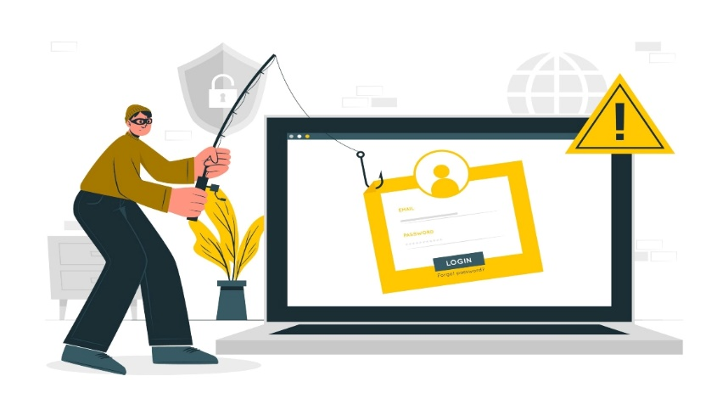

Sunil Bharadhwaj

# HOME PAGE

We have divided Phishing Domain Detection into Two Sections: -

1. Login/Signup :

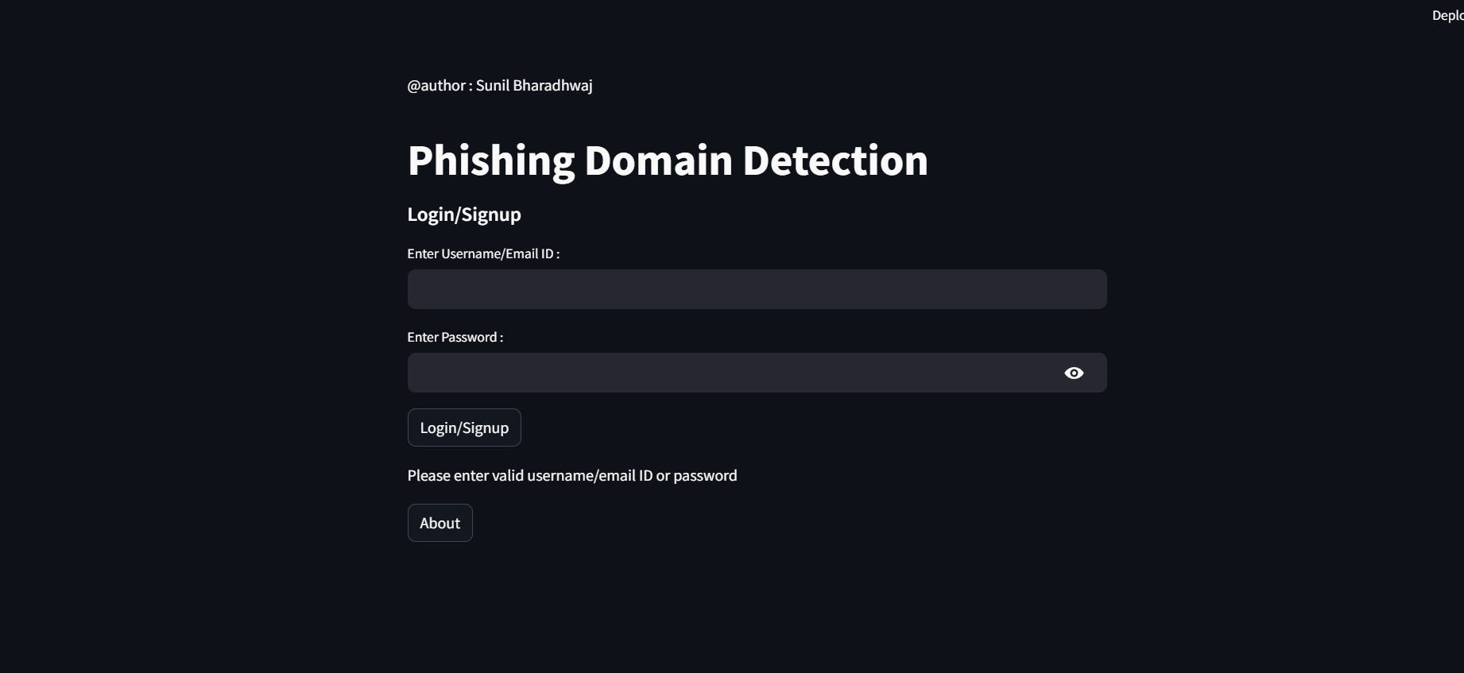

# PREDICTION PAGE

1. URL : After logging, user enters the URL, from which all 105 features are extracted.

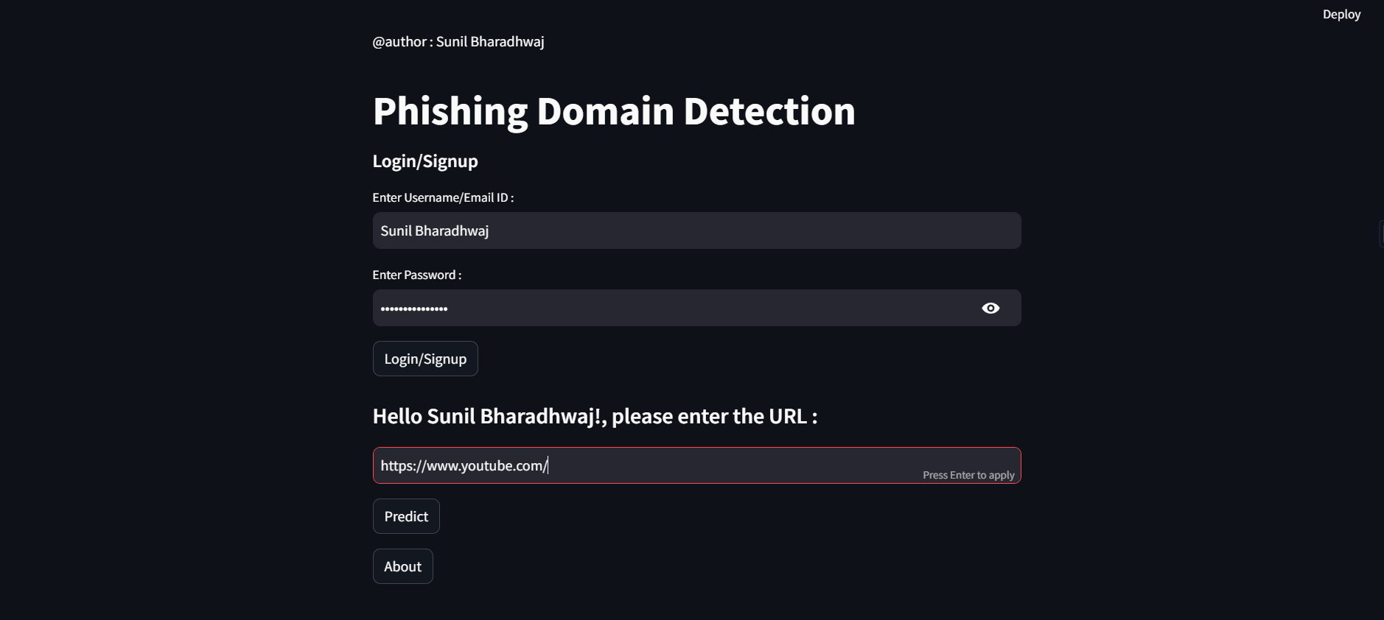

1. Site is safe :

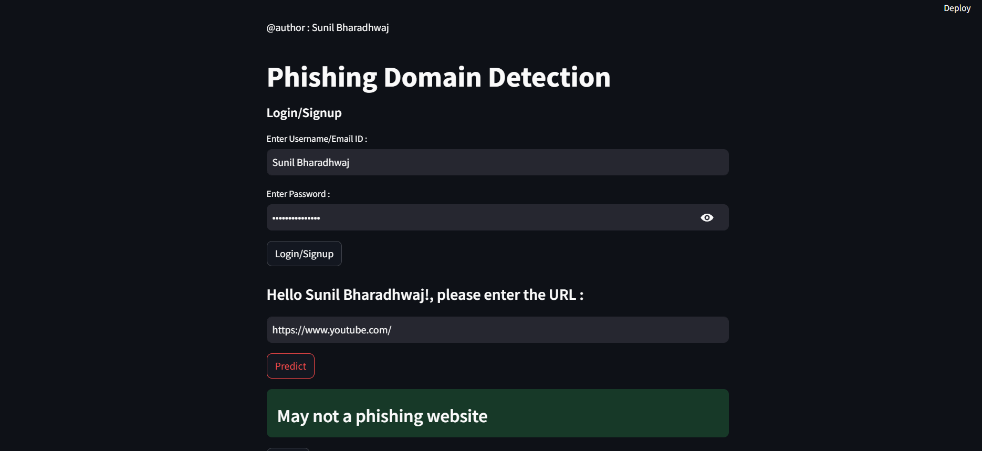

1. Site may not be safe :

